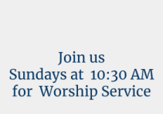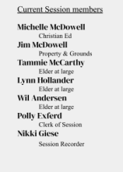

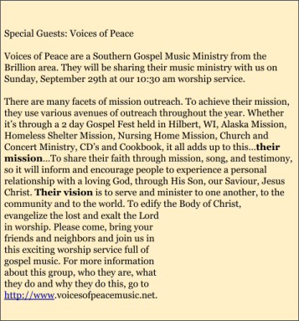





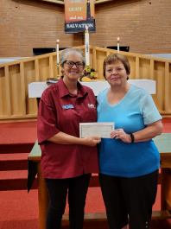





September 1 September 8 

|  |
| --- |
| **Duties** |
| Opening church |
| Greeter/usher |
| Snack provider |
| Hostess/closer |
| Weekly cleaning |

**Volunteer**

Polly Exferd Wil Anderson Michelle Bahrke Michelle Bahrke Comms Team

|  |  |
| --- | --- |
| **Duties** | **Volunteer** |
| Opening church | Polly Exferd |
| Greeter/usher | Dawn Steele |
| Snack provider | Michelle McDowell |
| Hostess/closer | Michelle McDowell |
| Weekly cleaning | Wil Anderson |

September 15 September 22

|  |
| --- |
| **Duties** |
| Opening church |
| Greeter/usher |
| Snack provider |
| Hostess/closer |
| Weekly cleaning |

**Volunteer**

Wil Anderson Martin Family Toni Hendzel Toni Hendzel Martha Krueger

|  |  |
| --- | --- |
| **Duties** | **Volunteer** |
| Opening church | Polly Exferd |
| Greeter/usher | Mlnarik Family |
| Snack provider | Rosemary Rice |
| Hostess/closer | Toni Hendzel |
| Weekly cleaning | Nikki Giese |

September 29

|  |  |
| --- | --- |
| **Duties** | **Volunteer** |
| Opening church | Polly Exferd |
| Greeter/usher | Wickman Family |
| Snack provider | Dawn Steele |
| Hostess/closer | Dawn Steele |
| Weekly cleaning | VOLUNTEER  NEEDED |

